ABSTRACT

For a working couple, it is hard to find time to have laundry day where the cloth is dried through the whole day because the weather can change from sunny to rainy days. People often forget to lift the suspension of clothing during the day rain. People often don’t have time to manage their routine.

Our project uses Microcontroller PIC16F877A to install all programs that will give instructions to conduct this system properly. This cloth retrieval system will introduce the techniques which will automatically retrieve-out the clothes when there is no rain and oppositely retrieve-in the clothes when it rains. Hence people don’t have to worry about their clothes that have been left outside for drying.

This part needs DC motor to convert electrical power into mechanical power for retrieve-out and retrieve-in all the clothes. Rain detector will be used to sense when it begins to rain outside by detecting rain water . We also use an indicator light such as LED (Light Emitting Diode) to show whether the system is on or off.

INTRODUCTION

People often forget to lift the suspension of clothing during the day rain. For people who working, they don’t have to worry about their clothes that have been dried outside. People often don’t have time to manage their routine. This project develop for working couple, it is hard to find time to have laundry day where the cloth is dried through the whole day because the weather can change from sunny to rainy days.
This project uses Microcontroller PIC16F877 to install all program that will give instructions to conduct this system properly and will automatically retrieve-out the clothes when it is the sunny day and oppositely retrieve-in the clothes when it is a rainy day.
The rain sensor input in sent to the microcontroller and processed according to the instructions stored in it and the hence computed output signals decide when to retrieve in or out the clothe line.
This part needs DC motor to convert electrical power into mechanical power for retrieve-out and retrieve-in all the clothes. Rain sensors that we use in this project can detect rain on an instantaneous basis. The simple concept that water is a good conductor of electricity is implemented here. Rain detector use to sense whether it rain or not at outside by detecting rain water from the loose ends of the rain sensor circuit.

PRINCIPLE OF OPERATION

The basic principle behind the working of the rain detector circuit is that
“salt water is a good conductor of electricity”.
As the loose ends of the rain detector circuit come in contact with rain water, the circuit gets completed and there is flow of charge through the components. The sensor sends a high data when it is raining, and low data when it is not, to the PIC microcontroller’s ADC pins.The incoming data is in analog, which is converted to digital form by the ADC. The result is stored in ADRESH and ADRESL registers of the memory.
The code fetches the required data and computes it according to the program written. Corresponding output is sent to the stepper motor driver.Therefore the cloth line is pulled in when it rains. And rolled out when it is not raining.

BLOCK DIAGRAM

BIPOLAR STEPPER
MOTOR

MOTOR
DRIVER IC MODULE
PIC16F877A
ADC
MODULE
RAIN SENSOR
CLOTHES-LINE

Fig 1:Block diagram

CIRCUIT DIAGRAM

RAIN SENSOR

Fig 2:Rain sensor circuit diagram

MAIN CIRCUIT

Fig 3:Circuit diagram

CIRCUIT DESCRIPTION

The automatic cloth retrieval system consists of PIC16F877A microcontroller, a simple rain sensor circuit, bipolar stepper motor and l298 bipolar stepper driver module.
Power supply: The PCB is powered on from the plug socket via an adapter. The 7805 voltage regulator IC provides +5V regulated power supply which is needed for the PIC.
Rain sensor circuit: A simple rain sensor circuit using resistors ,capacitor, transistor and a potentiometer is implemented for the purpose. When the two input wires with small metal rings attached to it(in order to increase the conductivity) come in contact with water the circuit gets closed .The output of this circuit is sent as the input to the built in analog to digital converter(ADC) of the microcontroller using the program burnt into the PIC.
PIC connections: The crystal oscillator is connected between pin 13 and 14.Four PORT B pins RB0,RB1,RB2,RB3 (pins 33-36) and four PORT C pins RC0,RC1,RC2,RC3 (pins 15-18) are used in this project. Pin 1 is connected to +5V.
Motor driver module: This module consists of L298 bipolar stepper motor driver IC, aluminum heat sink, capacitors, diodes. The L298 IC is powered on with +5V on pin 9.The wires from the stepper motor is connected to the output pins of L298 IC. The input pins of L298 IC is connected to the port pins of the PIC. The voltage required to drive the motor is given to the pin 4.

PCB LAYOUT

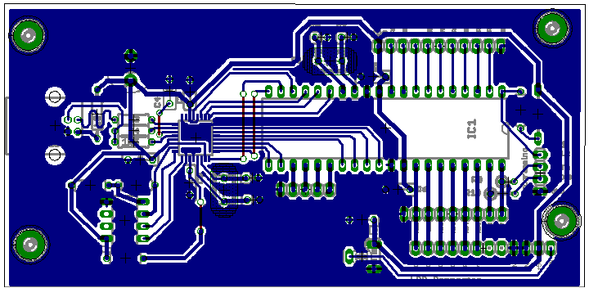
Fig 4:PCB layout

SOFTWARE

Initially we have included the header file pic.h in our program and have also set the operating frequency as 20MHz. PIC16F877A has a built in ADC with a 10 bit digital number as the output.
The first portion of the program is to configure this ADC module suitably as per our requirement. The ADC module uses four registers namely ADRESH(ADC Result High Register),ADRESL(ADC Result Low Register),ADCON0(ADC Control Register 0) and ADCON1(ADC Control Register 1).First we set the ADON bit of the ADCON0 register to turn on the ADC module. Then we select channel 0 by clearing the analog channel select bits(CHS2,CHS1,CHS0=000). Next the A/D Conversion Clock Select bits are set as 010 to select the clock conversion as Fosc/32.Later we configure the ADC Port Configuration Control Bits as 0000 (to consider the input as analog in all channels. Finally the ADFM bit of ADC0N1 register is set as 1 for right justified data in the ADRESH:ADRESL register pair.
Then PORT B and PORT C are configured as output ports by writing 0 to the corresponding Data Direction Registers. We also initialize these ports with 0 value.
The ADC process now begins. The 10 bit digital output gets stored in the ADRESH:ADRESL register as right justified data as mentioned above. The contents of ADRESH is moved to a variable ‘a’ of type int and is shifted to the left by 8 bits. Then bitwise addition is carried out between the data in ‘a’ and ADRESL .If the value in ‘a’ exceeds 300 ,RC2 is set. Else it is cleared. Similarly if the ‘a’ value is below 100,RC3 is set. Else it is cleared.fun1() is called if a>300 and if flag1 is set(ie ,if raining).fun2() is called in the other case.
RC0,RC1 are set and a variable ‘b’(used as a count for motor steps) is cleared under fun1() and fun2().
Inside fun1() a while loop is used with the condition b<197.Inside the while loop PORT B is given a value 0x08(implying that the cloth line is at the extreme position) and then a delay function is called The PORT B value is decremented (ie, the cloth line is brought inwards) and

the same delay function is called under a for loop. Outside the for loop the value of ‘b’ is incremented.RC0,RC1 and flag1 are cleared and flag2 is set outside fun1() .
fun2() is also defined similarly with the only change in giving 0x01 to PORT B(implying that the cloth line is in the initial position).Inside the for loop the PORT B value is incremented (ie ,the cloth line is pushed outwards).Outside fun2() RC0,RC1 and flag2 are cleared and flag1 is set.
ABOUT THE DEVELPOMENT SOFTWARE:
The MPLAB IDE software brings an ease of software development previously unseen in the 8-bit microcontroller market.
The MPLAB IDE is a Windows-based application that contains:
• An interface to debugging tools
- simulator
- programmer (sold separately)
- emulator (sold separately)
- in-circuit debugger (sold separately)
• A full-featured editor
• A project manager
• Customizable toolbar and key mapping
• A status bar
• On-line help
The MPLAB IDE allows you to:
• Edit your source files (either assembly or ‘C’)
• One touch assemble (or compile) and download to PICmicro emulator and simulator tools (automatically updates all project information)
• Debug using:
- source files
- absolute listing file

- machine code
The ability to use MPLAB IDE with multiple debugging tools allows users to easily switch from the costeffective simulator to a full-featured emulator with minimal retraining.

Steps to work on MPLAB IDE are:
- Select the device e.g. the PIC16F877A.
- Use the Project Wizard to create a project, and using the wizard to:
• select the MPLAB IDE built in MPASM assembler and MPLINK linker language tools,
• add files for the project: a template file for the device selected and a linker script to build it properly.
- Write some simple code to send a changing value out an I/O port.
- Build the project.
- And finally, test the code with the simulator.

PROGRAM CODE
#include<pic.h>
#define _XTAL_FREQ 20E6
void fun1();
void fun2();
int flag1=1, flag2=1, b=0;
void main()
{
int a=0;
ADON=1; //ADC enable
CHS0=0; //channel select
CHS1=0;
CHS2=0;
ADCS0=0; //frequency enable
ADCS1=1;
ADCS2=0;
PCFG0=0; //set to analog format
PCFG1=0;
PCFG2=0;
PCFG3=0;
ADFM=1; //right justified data
TRISB=0x00; //set port B as output
TRISC=0x00; //set port C as output
PORTB=0x00; //initialize the port
PORTC=0x00;
while(1)
{
GO=1;

while(GO==1);
a=ADRESH;
a=a<<8; //copy higher bits to a and shift
a=a|ADRESL; // bitwise addition
if(a>512)
{ RC2=1;}
else
{RC2=0;}
if(a<500)
{ RC3=1;}
else
{RC3=0;}
if(a>512 && flag1==1) //condition for raining
{ fun1();}
if(a<500 && flag2==1) //condition for no rain
{fun2();}
}
void fun1()
{
RC0=1;
RC1=1; b=0;
while(b<197)
{
PORTB=0x08;
__delay_ms(9);
for(int c=0;c<3;c++)
{
PORTB=PORTB>>1; //clothes line pulled inside

__delay_ms(9);
}
b++;
}
RC0=0;
RC1=0;
flag1=0;
flag2=1;
}
void fun2()
{
RC0=1;
RC1=1; b=0;
while(b<197)
{
PORTB=0x01;
__delay_ms(9);
for(int c=0;c<3;c++)
{
PORTB=PORTB<<1; //clothes line pushed outside
__delay_ms(9);
}
b++;
}
RC0=0;
RC1=0;
flag2=0;
flag1=1;
}

COMPONENTS

MICROCONTROLLER : PIC16F877A
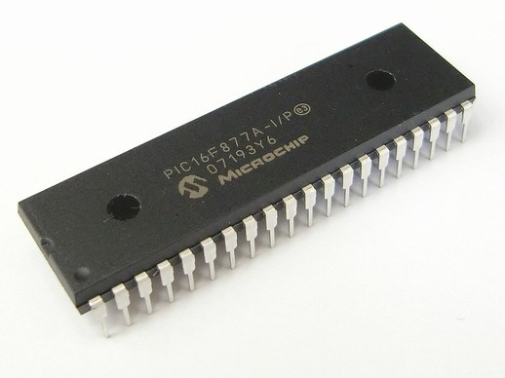
Fig 5:PIC16F877A

The PIC microcontroller PIC16F877A is one of the most renowned microcontrollers in the industry.This controller is very convenient to use and the coding or programming of this controller is also easier.One of the main advantage is that it can be written and erased as many timesas possible because it use FLASH memory technology.It has a total number of 40 pins and there are 33 pins for input and output.PIC16F877A finds it’s applications in a number of devices.An EPROM is also featured in it which makes it possible to store some of the information permanently.The cost of this controller is low and it’s handling is also easy.

High-Performance RISC CPU:
- Only 35 single-word instructions to learn
- All single-cycle instructions except for program branches, which are two-cycle
- Operating speed: DC – 20 MHz clock input
DC – 200 ns instruction cycle
- Up to 8K x 14 words of Flash Program Memory,
Up to 368 x 8 bytes of Data Memory (RAM),
Up to 256 x 8 bytes of EEPROM Data Memory
- Pinout compatible to other 28-pin or 40/44-pin PIC16CXXX and PIC16FXXX microcontrollers

Peripheral Features:
- Timer0: 8-bit timer/counter with 8-bit prescaler

- Timer1: 16-bit timer/counter with prescaler,can be incremented during Sleep via external crystal/clock
- Timer2: 8-bit timer/counter with 8-bit period register, prescaler and postscaler
- Two Capture, Compare, PWM modules
- Capture is 16-bit, max. resolution is 12.5 ns
- Compare is 16-bit, max. resolution is 200 ns
- PWM max. resolution is 10-bit
- Synchronous Serial Port (SSP) with SPI (Master mode) and I2C™ (Master/Slave)
- Universal Synchronous Asynchronous Receiver Transmitter (USART/SCI) with 9-bit address detection
- Parallel Slave Port (PSP) – 8 bits wide with external RD, WR and CS controls (40/44-pin only)
- Brown-out detection circuitry for Brown-out Reset (BOR)

Analog Features:
- 10-bit, up to 8-channel Analog-to-Digital Converter (A/D)
- Brown-out Reset (BOR)
- Analog Comparator module with:
- Two analog comparators
- Programmable on-chip voltage reference (VREF) module
- Programmable input multiplexing from device inputs and internal
voltage reference
- Comparator outputs are externally accessible

Special Microcontroller Features:
- 100,000 erase/write cycle Enhanced Flash program memory typical
- 1,000,000 erase/write cycle Data EEPROM memory typical
- Data EEPROM Retention > 40 years
- Self-reprogrammable under software control

- In-Circuit Serial Programming™ (ICSP™) via two pins

- Single-supply 5V In-Circuit Serial Programming
- Watchdog Timer (WDT) with its own on-chip RC oscillator for reliable operation
- Programmable code protection
- Power saving Sleep mode
- Selectable oscillator options

- In-Circuit Debug (ICD) via two pins

CMOS Technology:
- Low-power, high-speed Flash/EEPROM technology
- Fully static design
- Wide operating voltage range (2.0V to 5.5V)
- Commercial and Industrial temperature ranges
- Low-power consumption

BLOCK DIAGRAM:

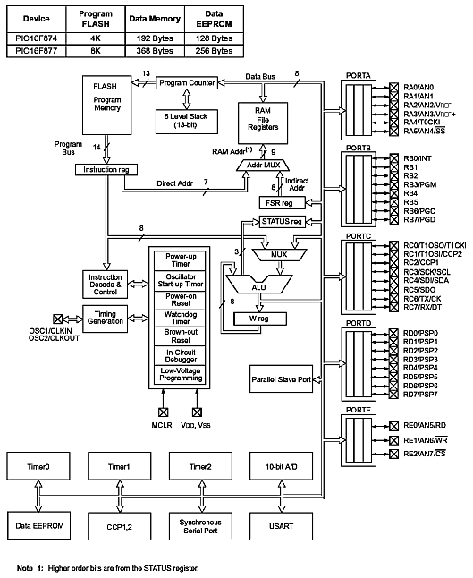

Fig 6: Block diagram of PIC16F877A

PIN CONFIGURATION

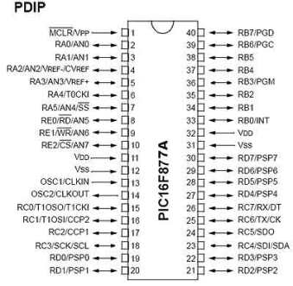
Fig 7:Pin diagram of PIC16F877A

PIN DESCRIPTION:

PIN 1: MCLR/RE3/Vpp

MCLR-The first pin is the master clear pin of this IC. It resets the microcontroller and is active low, meaning that it should constantly be given a voltage of 5V and if 0 V are given then the controller is reset. Resetting the controller will bring it back to the first line of the program that has been burned into the IC.
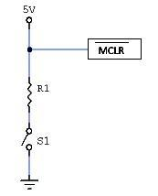
A push button and a resistor is connected to the pin. The pin is already being supplied by constant 5V. When we want to reset the IC we just have to push the button which will bring the MCLR pin to 0 potential thereby resetting the controller.
Vpp- Programming voltage

PIN 2: RA0/AN0
PORTA consists of 6 pins, from pin 2 to pin 7, all of these are bidirectional input/output pins. Pin 2 is the first pin of this port. This pin can also be used as an analog pin AN0. It is built in analog to digital convertor.
PIN 3: RA1/AN1
This can be the analog input 1 or the second pin of PORT A.
PIN 4: RA2/AN2/Vref-
It can also act as the analog input2 or the third pin of PORT A. Or negative analog reference voltage can be given to it.
PIN 5: RA3/AN3/Vref+
It can act as the analog input 3 or the fourth pin of PORT A. Or can act as the analog positive reference voltage.

PIN 6: RA4/T0CKI
This pin can act as the fifth pin of PORT A.To timer0 this pin can act as the clock input pin, the type of output is open drain.
PIN 7: RA5/SS/AN4
This can be the analog input 4 or the sixth pin of PORT A. There is synchronous serial port in the controller also and this pin can be used as the slave select for that port.
PIN 8: RE0/RD/AN5
PORT E starts from pin 8 to pin 10 and this is also a bidirectional input output port. It can be the analog input 5 or for parallel slave port it can act as a ‘read control’ pin which will be active low.
PIN 9: RE1/WR/AN6
It can be the analog input 6 or the second pin of PORT E. And for the parallel slave port it can act as the ‘write control’ which will be active low.
PIN 10: RE2/CS/A7
It can be the analog input 7 or the third pin of PORT E, or for the parallel slave port it can act as the ‘control select’ which will also be active low just like read and write control pins.
PIN 11 and 32: VDD
These two pins are the positive supply for the input/output and logic pins. Both of them should be connected to 5V.
PIN 12 and 31: VSS
These pins are the ground reference for input/output and logic pins. They should be connected to 0 potential.
PIN 13: OSC1/CLKIN
This is the oscillator input or the external clock input pin.
PIN 14: OSC2/CLKOUT
This is the oscillator output pin. A crystal resonator is connected between pin 13 and 14 to provide external clock to the microcontroller. ¼ of the frequency of OSC1 is outputted by OSC2 in case of RC mode. This indicates the instruction cycle rate.
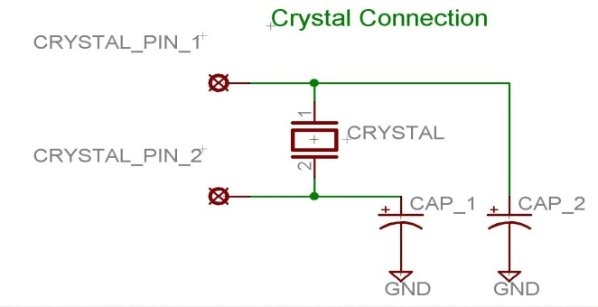
Fig 8:Crystal connection for PIC16F877A

PIN 15: RC0/T1OCO/T1CKI
PORTC consists of 8 pins. It is also a bidirectional input output port. Of them, pin 15 is the first. It can be the clock input of timer 1 or the oscillator output of timer 2.
PIN 16: RC1/T1OSI/CCP2
It can be the second pin of PORT C.It can be the oscillator input of timer 1 or the capture 2 input/compare 2 output/ PWM 2 output.
PIN 17: RC2/CCP1
It can be the third input of PORT C.It can be the capture 1 input/ compare 1 output/ PWM 1 output.
PIN 18: RC3/SCK/SCL
It can be the output for SPI or I2C modes and can be the input/output for synchronous serial clock.It can also be the fourth input of PORT C.
PIN 23: RC4/SDI/SDA
It can be the SPI data in pin. Or in I2C mode it can be data input/output pin.Or the fifth PORT C pin.
PIN 24: RC5/SDO
It can be the data out of SPI in the SPI mode.Or the sixth PORT C pin.
PIN 25: RC6/TX/CK
It can be the synchronous clock or USART Asynchronous transmit pin also it can be the seventh pin of PORT C.
PIN 26: RC7/RX/DT
It can be the synchronous data pin or the USART receive pin or the last pin of PORT C.
PIN 19,20,21,22,27,28,29,30:
All of these pins belong to PORTD which is again a bidirectional input and output port. When the microprocessor bus is to be interfaced, it can act as the parallel slave port.
PIN 33-40: PORT B
All these pins belong to PORTB. Out of which RB0 can be used as the external interrupt pin and RB6 and RB7 can be used as in-circuit debugger pins.

ADC CONFIGURATION:

LM 7805:

Fig 9:LM 7805

7805 is a voltage regulator integrated circuit. It is a member of 78xx series of fixed linear voltage regulator ICs. The voltage source in a circuit may have fluctuations and would not give the fixed voltage output. The voltage regulator IC maintains the output voltage at a constant value.The xx in 78xx indicates the fixed output voltage it is designed to provide. 7805 provides +5V regulated power supply. Capacitors of suitable values can be connected at input and output pins depending upon the respective voltage levels.

FEATURES:
- Output Current up to 1A
- Output Voltages of 5, 6, 8, 9, 10, 12, 15, 18, 24V
- Thermal Overload Protection
- Short Circuit Protection
- Output Transistor Safe Operating Area Protection

This series of fixed-voltage integrated-circuit voltage regulators is designed for a wide range of applications. These applications include on-card regulation for elimination of noise and distribution problems associated with single-point regulation. The internal current-limiting

and thermal-shutdown features of these regulators essentially make them immune to overload. In addition to use as fixed-voltage regulators, these devices can be used with external components to obtain adjustable output voltages and currents, and also can be used as the power-pass element in precision regulators.

Fig10:Internal block diagram of LM 7805

L298 Bipolar Stepper Driver Module:

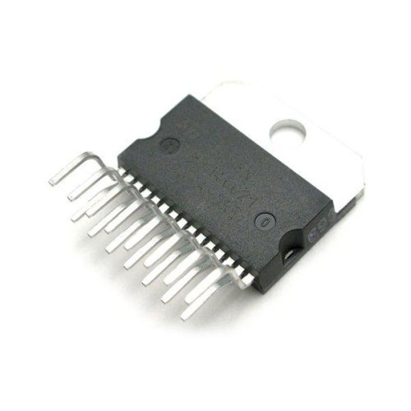
Fig11:L298 IC

A very popular and reasonably priced all-in-one H-bridge motor driver is the L298. It can control two motors, not just one. The L298 has a large cooling flange with a hole in it, making it easy to attach a homebrew metal heat sink to it.
The L298 “Multiwatt 15” package has 15 offset pins that don’t match the standard 0.100" spacing of breadboards. But with care, the pins can be rebent as needed.
The L298 uses two different supply voltages. The voltage on pin 9 powers the chip itself and should be 5 volts. The voltage on pin 4 supplies the motors, and it can be up to 46 volts.
The L298 does not have built-in protection diodes, so you’ll need to add those. During the on-time the motor will build an electromagnetic field inside it. When the switch is turned off, that field has to collapse, and until that happens, current must still flow through the windings. That current cannot flow through the switches since they are off, but it will find a way. The catch diodes, are in the design to provide a low-resistance path for that collapse current and thus keep the voltage on the motor terminals within a reasonable range.
The motor will forward-bias a diode (or diodes) in the bridge to create a route for that current, however the turn-on delay of the diodes will create a problem. Worst, this will happen at the point where the motor-current is at its maximum. Without mitigation the motor voltage can rise to dangerous levels and damage the switching elements. To bridge this interval where neither the switches nor the diodes conduct a capacitor has to be connected to the terminals of the motor. Some motors contain this capacitor already, but many require an external one. This capacitor will conduct the current until the diodes take over.

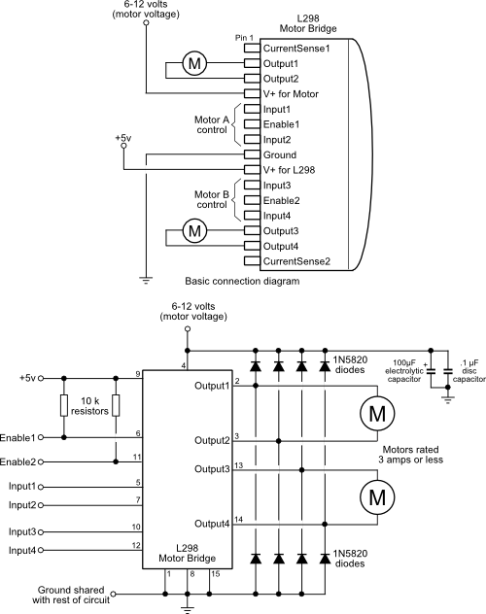

Fig 12:L298 IC pin diagram and connections

In order to activate the motor, the Enable1 line must be HIGH. We then control the motor and its direction by applying a LOW or HIGH signal to the Input1 and Input2 lines, as shown in this table.
Input 1 | Input 2 | Action
LOW | LOW | Motor breaks and stops*
HIGH | LOW | Motor turns forward
LOW | HIGH | Motor turns backward
HIGH | HIGH | Motor breaks and stops*

Bipolar Stepper Motor:
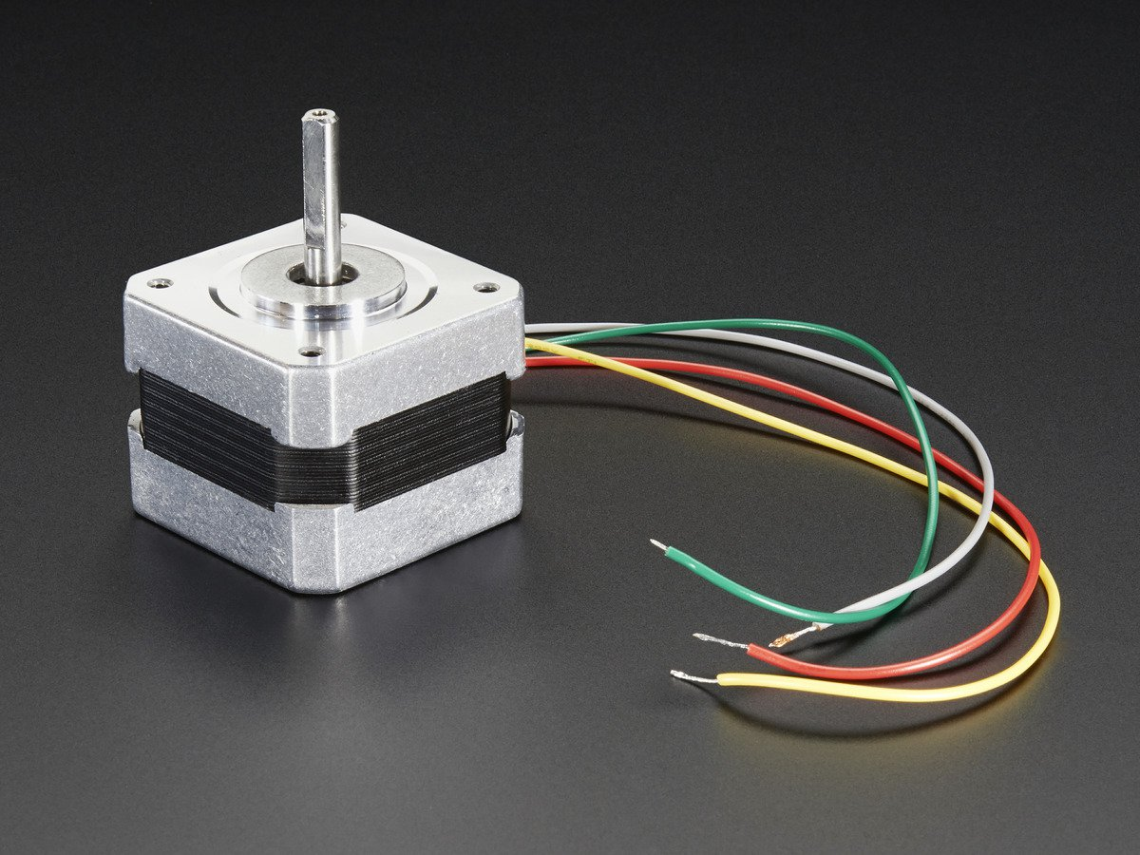
Fig13:Bipolar stepper motor

A stepper motor is a motor controlled by a series of electromagnetic coils. The center shaft has a series of magnets mounted on it, and the coils surrounding the shaft are alternately given current or not, creating magnetic fields which repulse or attract the magnets on the shaft, causing the motor to rotate.The bipolar stepper motor usually has four wires coming out of it. Unlike unipolar steppers, bipolar steppers have no common center connection. They have two independent sets of coils instead and stepping the motor round is achieved by energising the coils and changing the direction of the current within those coils. Like other motors, stepper motors require more power than a microcontroller can give them, so you’ll need a separate power supply for it. To control the stepper, apply voltage to each of the coils in a specific sequence. The sequence would go like this:

Step | wire 1 | wire 2 | wire 3 | wire 4
1 | High | low | high | low
2 | low | high | high | low
3 | low | high | low | high
4 | high | low | low | high

CONCLUSION AND SCOPE OF THE PROJECT

It gives me immense pleasure for having completed my project successfully. This project helped me to enhance my skill and I could also understood how the microcontroller
reduces the circuit and performs the function accurately.Through this project I have understood the applications of the microcontroller.
It was my great opportunity to work on this project “Monsoon Friendly Clothes-Line”. Through this project I have learnt the P.C.B. designing, layout preparation, burning of the microcontroller, tinning. It am satisfied because I have learnt something new from the
project which will surely help me in my technical life.
The main advantage of our cloth retrieval system is that it will reduce our work and save our time. It is compatible with climate changes as the sensors are used. As the device is simple it can be used by any kind of user. This prototype is less expensive.
I think my efforts may lead to new innovation in extending this project.I have prepared this report so that one can easily understand the project and if anyone wants to extend it can easily do so.

Further developments on the project include:
- Using GSM module, messages about the status of the device could be sent to the user’s mobile.
- The dry time of the clothes could be set up using push buttons and it would automatically retrieve in the clothes using DC motor when the dry time is finished.
- The shed used to store the clothes could also be used for rain water harvesting.
- The shed can be covered with solar panels for power purposes.

I could also realize how theoretical knowledge could be used to make a new project and also how to utilize our potential for new
innovations. I clearly understood the difference between the theoretical knowledge and the practical knowledge while doing this project.

In making this project I found a few problems related to the component availability. I have found the substitute to every component which has the same operation and working.This
helped me to know different types of components. I learnt how components are classified according to the performance. I also went through the specifications of the components. I also noticed that different companies manufacture the same component with a different name and the serial number.
Finally, I would like to say that my concept can be utilized in the manufacturing of the low cost, easy to use Monsoon Friendly Clothes-Line.

REFERENCES

- www.microchip.com

- www.microcontrollerslab.com

- www.circuitstoday.com

- www.electronicshub.com

- www.instructables.com

- www.learningaboutelectronics.com

- www.ianstedman.co.uk

- www.google.images.com

APPENDIX I

List of figures
- Block diagrams
Device block diagram : Page-4
PIC16F877A block diagram : Page-18
LM7805 internal block diagram : Page-26
- Circuit diagrams
Rain sensor circuit diagram : Page 5
Main circuit diagram : Page6
- PCB layout : Page-8
- Pin diagrams and figures
PIC16877A : Page-15 & 19
LM7805 : Page-25
L298 : Page-28 & 29
Bipolar Stepper Motor : Page -30
Crystal connection for PIC : Page 21

APPENDIX II
BILL OF MATERIALS
Sl.No. | ITEM | SPECIFICATION | QUANTITY | AMOUNT
1. | Microcontroller | PIC16F877A | 1 | 250
2. | Stepper motor driver IC board | L298 stepper driver | 1 | 300
3. | Stepper motor +  dot matrix printer frame |  | 1 | 650
4. | Resistor | 1 kilo ohm | 3 | 3
5. | Capacitor | 1000 micro farad  100 micro farad  100000 pico farad  0.1 micro farad | 1  1  5  2
6. | Crystal oscillator | 11.0592MHZ | 1 | 10
7. | LED |  | 1 | 1
8. | Acrylic sheet |  | 1.5 sq.feet | 300
9. | Adaptor | Input :220-230 V AC  50 Hz 0.15A  Output:5 V DC | 1 | 90
10. | Transistor | BC547 | 1
 | TOTAL

